SPREADSHEET JOURNAL ENTRY TEMPLATE INSTRUCTIONS
The Spreadsheet Journal Entry Template allows users to enter journal entries into the Workday system. It is a “Read-Only” protected Excel workbook. Data can only be entered into unprotected cells. The template performs both a validation and edit process to detect input errors and will prompt users for correct information
Do not use this template to adjust budgets. There is an electronic form for budget adjustments.
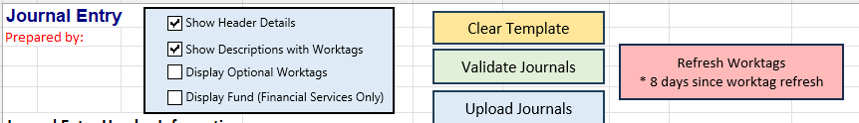
Show Header Details: This toggle button allows the header information to be hidden while working on the journal lines when unchecked.
Show Descriptions with Worktags: This toggle button allows you to choose worktags by typing in descriptions instead of only showing the worktag number. If the box is unchecked, you can copy and paste worktag information directly into the line fields.
Display Optional Worktags: This toggle allows you to input optional worktag information when applicable such as Class, Assignee, Exp Learning & Research, and Company before uploading your journal entry.
Display Fund (Financial Services Only): Generally users should not change the Fund defaulted for the driver worktags chosen. This toggle switch allows the user to change the fund and should only be used by Financial Services.
Journal Header
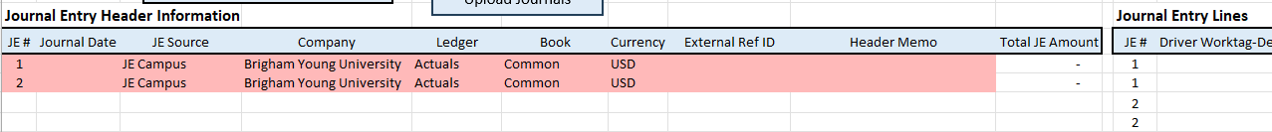
The header section will remain pink until you have completed all required information then the color will disappear.
JE #: The user may load multiple journal entries on the spreadsheet template. For each journal entry you will designate in the header section the number of the journal entry. This connects the “Journal Entry Header Information” to the specific lines on the opposite side of the page in the “Journal Entry Lines” section.
Journal Date: The journal date is the date of the journal. This date input must be in an open period. Journal date cannot be for a previously closed month.
Journal Source: Campus users should always choose “JE Campus” as the journal source.
Company: Most campus users should choose “Brigham Young University” as the company. Only use a different company if you understand the use of the other companies and are authorized to use them.
Ledger: Most campus users will always choose the “Actuals” ledger.
Book: Most campus users will always choose the “Common” book.
External Ref ID: This is similar to the Journal ID in PeopleSoft. This is one of the ways you will be able to identify the journal in Workday. This field should be unique for each journal entry. We recommend that users populate this field with NetIDyymmdd… (EX. if your NetID is kn1 and the date is 10/01/2024 your external ref ID would be kn124100101).
Header Memo: This is similar to the journal header description in PeopleSoft. This field should explain the purpose of the journal entry. It should be detailed enough that someone not directly involved in the transaction will understand what is happening and why. There is not a limitation on the number of characters for this field.
Total JE Amount: Users should not do anything in this field. The spreadsheet journal entry template will calculate this field for you.
Journal Entry Lines
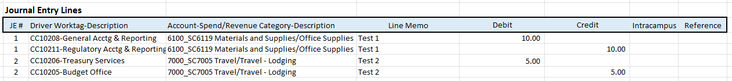

JE #: This should correspond to the JE # in the “Journal Entry Header Information”. It should be populated with the number of the journal entry that the line relates to.
Driver Worktag-Description: To populate this you may type start typing either the worktag or description. As you type the template will show you the list of worktags that match what you have typed. Choose the driver worktag you want from the list.
Account-Spend/Revenue Category-Description: To populate this you may type start typing either the worktag or description. As you type the template will show you the list of worktags that match what you have typed. Choose the account_spend/revenue category-description you want from the list. It is possible to choose only a ledger account but most of the time you will want to choose a ledger account and spend/revenue category so carefully consider your choice. This will affect the way you will be able to pull detail in reporting later on.
Line Memo: This is similar to the journal line description in PeopleSoft. This field should provide any additional information about the journal line that you want to be able to pull in reporting. It should be detailed enough that someone not directly involved in the transaction will understand what is happening and why. There is not a limitation on the number of characters for this field.
Debit and Credit: Users may not fill in both a debit and credit amount on the same line. Choose one or the other. Your debits must equal your credits for each journal entry.
Intracampus: If this is an intracampus transaction then click on the cell in the Intracampus column and choose “Yes” in the drop-down menu. If it is not an intracampus transaction then leave it blank.
Reference: This field is optional and can be used much like the Reference field in PeopleSoft. It can be populated by any meaningful information that the user wants. It does not have a limitation on the number of characters.

When you have finished filling out the template you are ready to upload your journal entries.
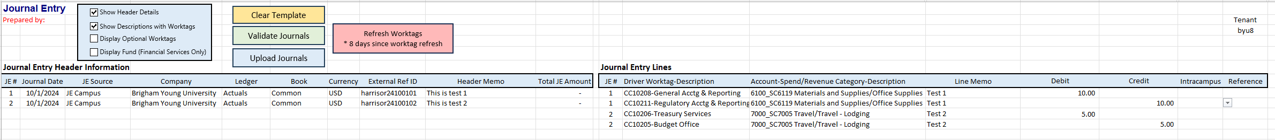

Load JE from Spreadsheet Template

- Fill out the spreadsheet JE template (for more information on how to complete a spreadsheet JE, refer to ‘Spreadsheet Journal Entry Template Instructions’):
- Click the ‘Upload Journals’ button. Workday will open and go to the ‘Launch / Schedule Integration’ page. The ‘Integration’ field should automatically populate with the ‘BYU Import EIB Journal’ integration and the ‘Run Frequency’ field should automatically populate with ‘Run Now’. For most of campus the organization will be ‘Brigham Young University’. Click the “OK” button.
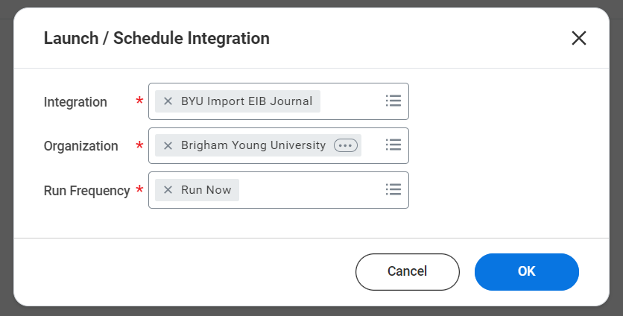

- The system will take you to the ‘Schedule an Integration’ page. In the ‘Integration Attachment’ row, in the Value field, select ‘Create Integration Attachment’.
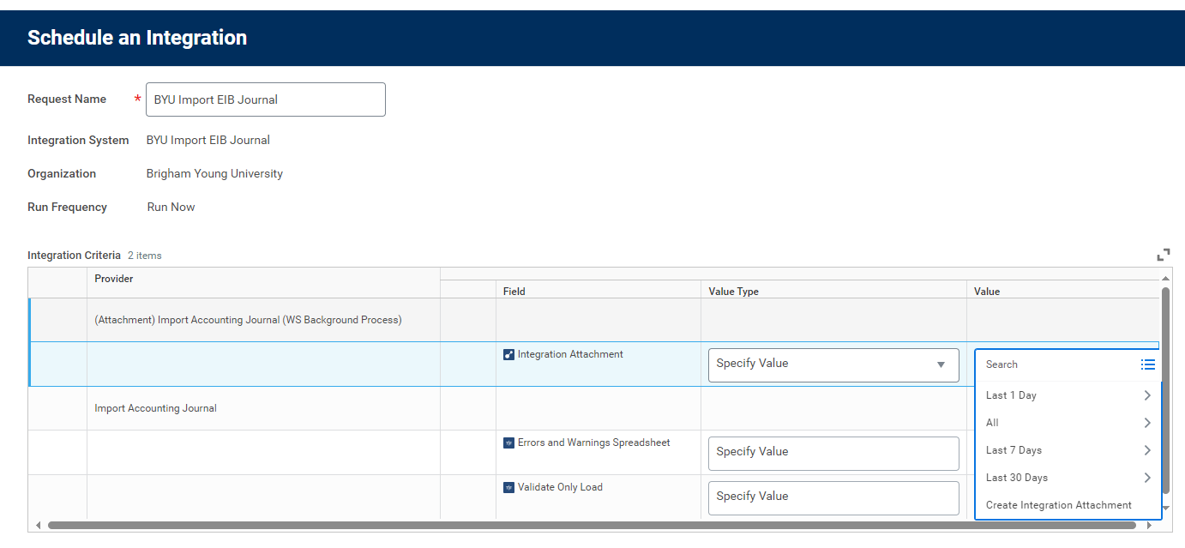
- The ‘Create Integration Attachment’ page will open. Drag and drop your file in the space indicated. Click the “Upload” button then click “OK”.

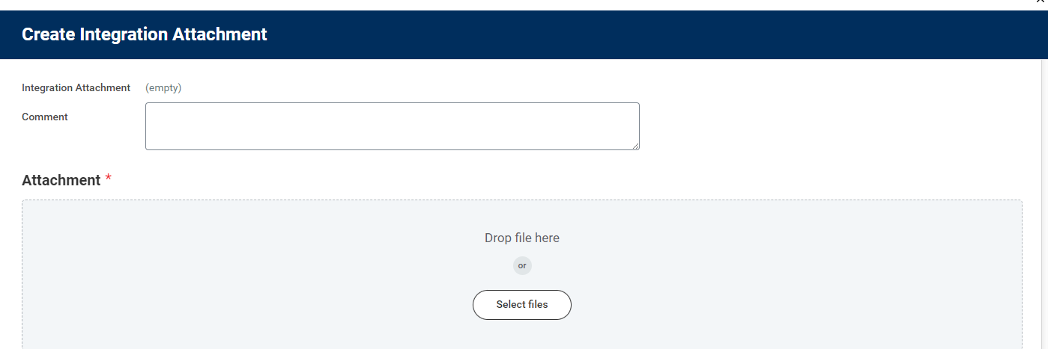
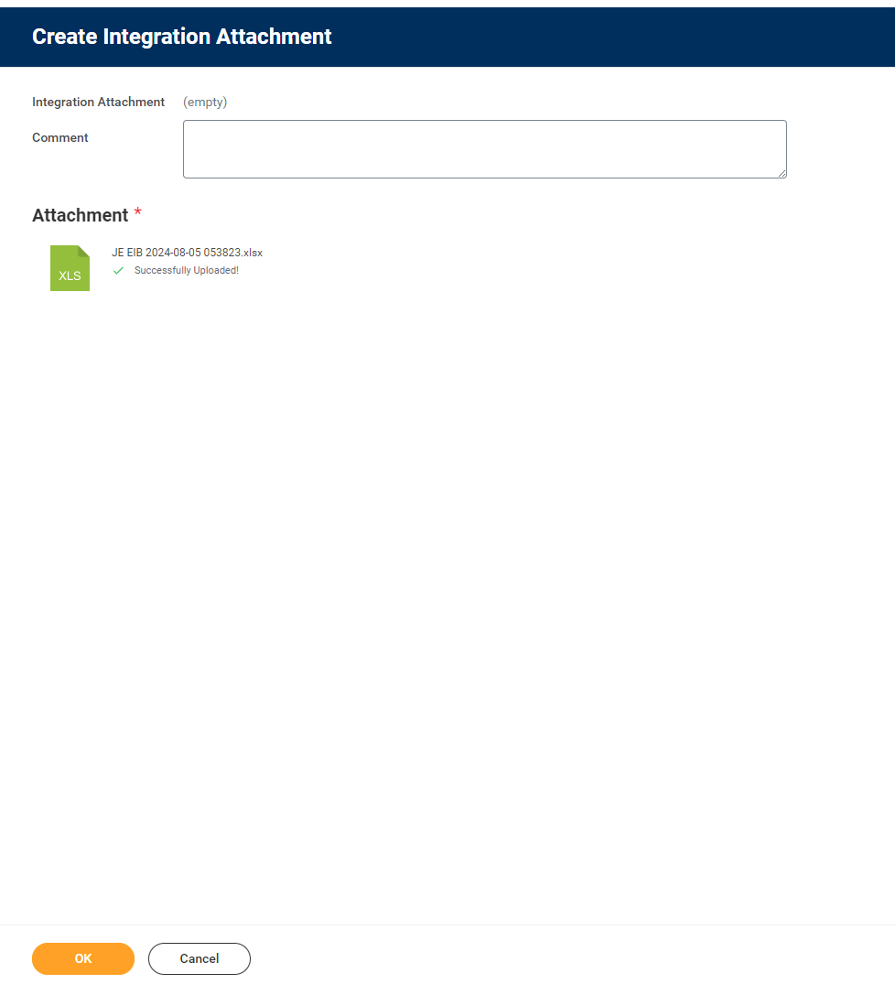

- Click “OK” again.
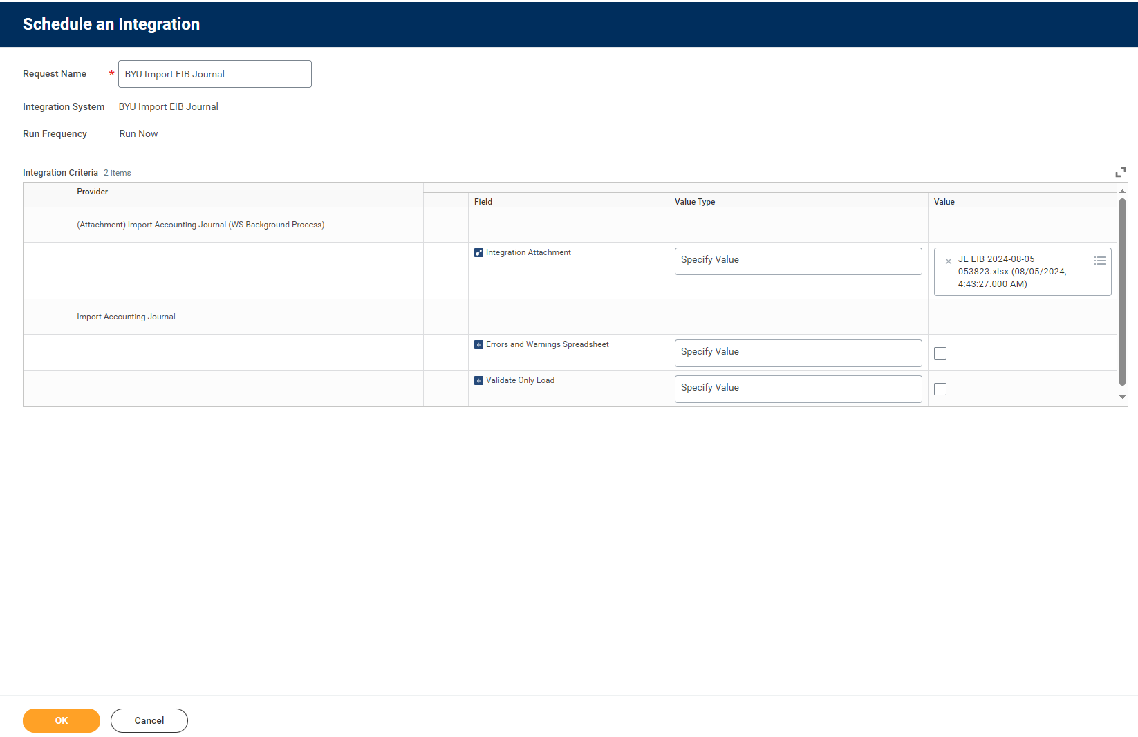

- Click Refresh button until the process shows complete.
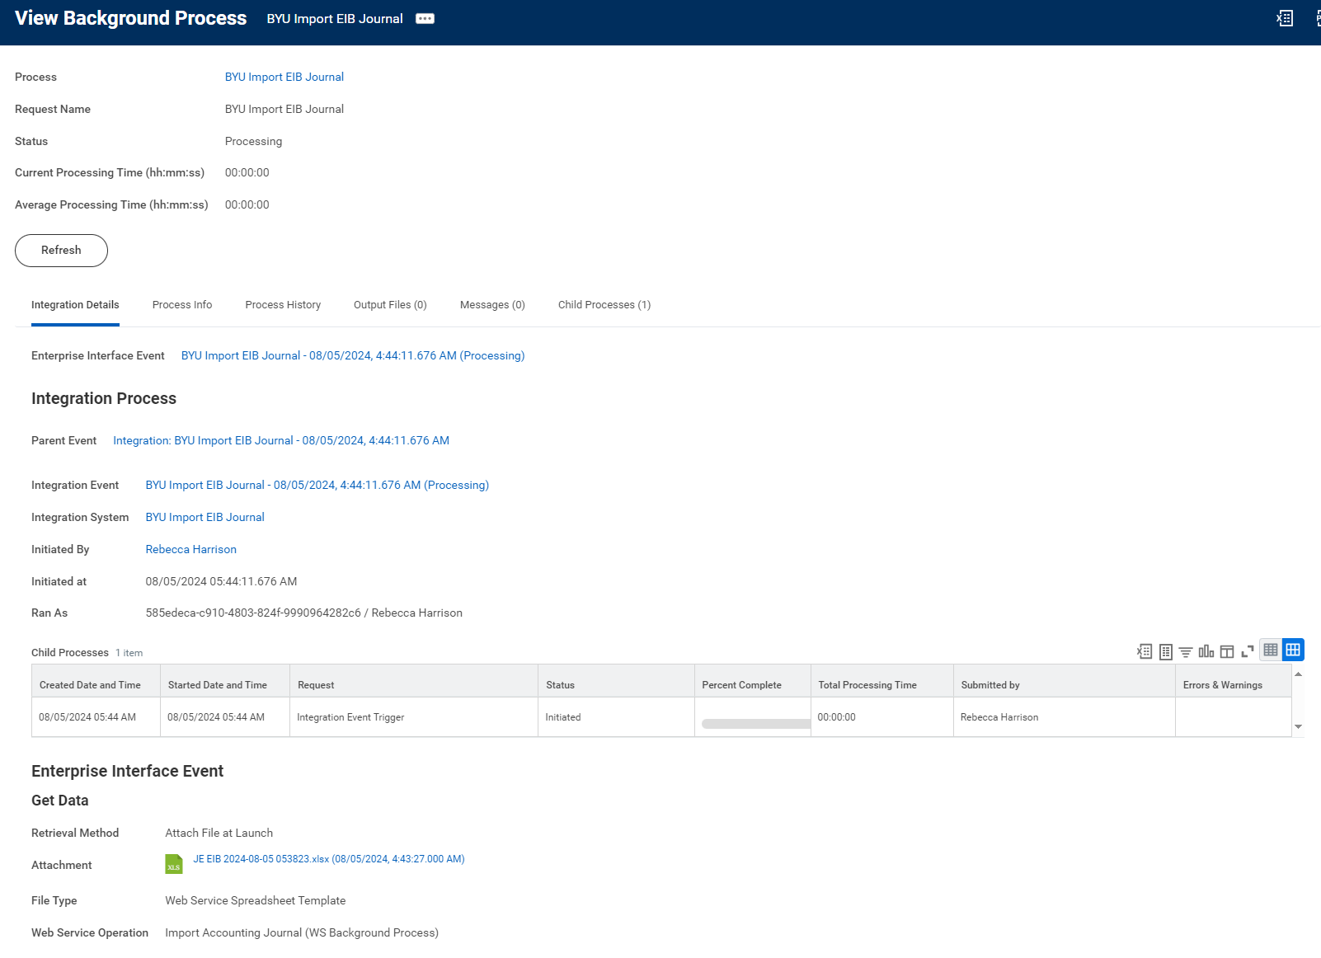

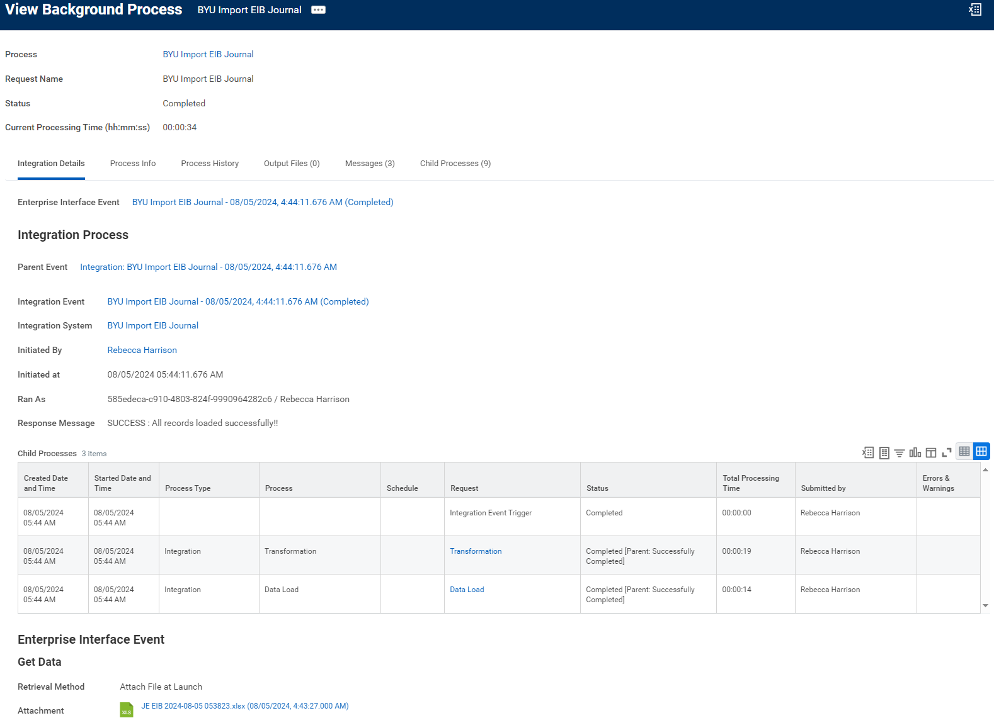

- Go to your ‘My Tasks’ list and click on the journal you just created. Click on the ‘Attachments’ tab and either drag and drop the backup documentation or click on the ‘Select Files’ button and find the documentation file(s) to add. If everything looks good, click the ‘Approve’ button:
