Submitting a Security Access Request for Student Administration

Prior to submitting a Security Access Request for the PeopleSoft Student Administration system, all employees, including students, staff, and administrators are required by the University to complete the on-line FERPA compliance training. FERPA training is required every two years.

Navigation

The Security Access Request Home Page is located in the PeopleSoft Human Resources / Payroll system. Access to the HR system is given to Security Access Coordinators or SACs for each campus department. All request for PeopleSoft Student Administration access should be coordinated through this employee. The SAC is typically the Controller or Administrative Assistant for the department.

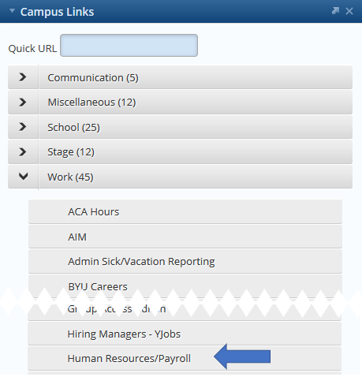
To navigate to the Human Resources / Payroll system:

- Log into myBYU (authenticated via CAS)
- Locate and open the Campus Links portlet
- Locate and open the Work folder
- Locate and open Human Resources / Payroll

The appearance of tiles on the HR / Payroll Home Page will vary depending on user access. In this example the Security Request Home Page is on My Homepage; the tile acts as a link directly to the page. Users may also select “Hiring” from the dropdown menu to locate this tile.


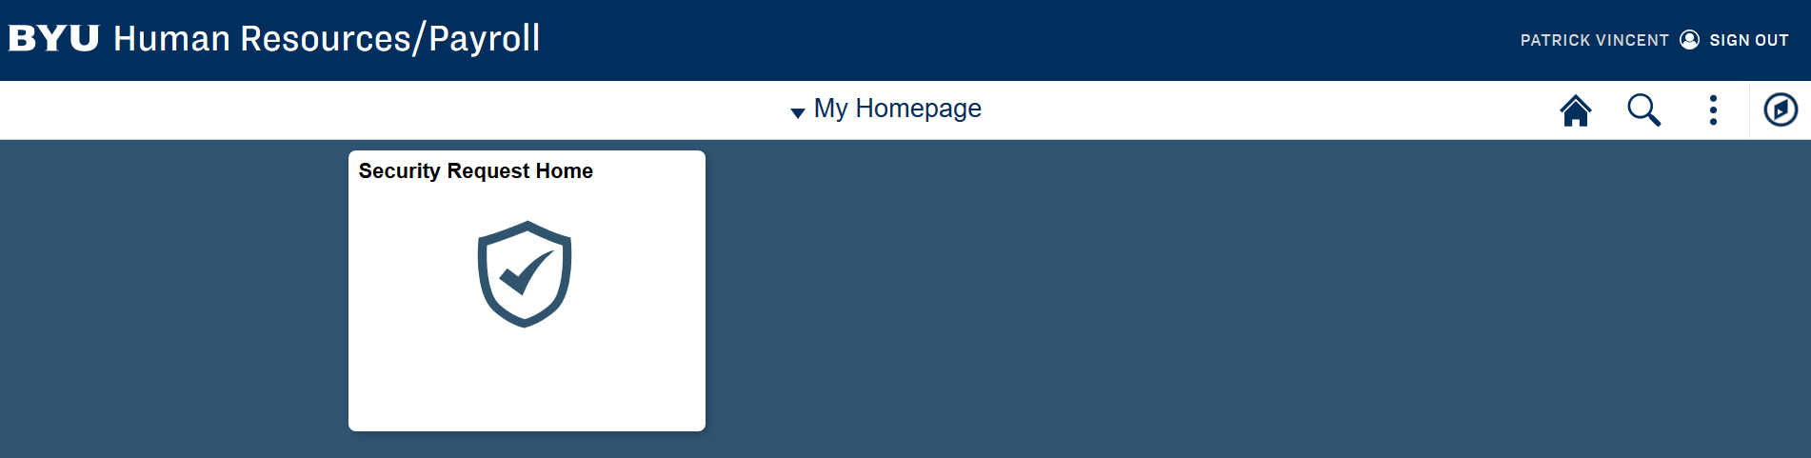

Alternatively, users may select the NavBar button  to navigate the menu options as follows:

BYU Menu > Department Self Service > Security Request Home

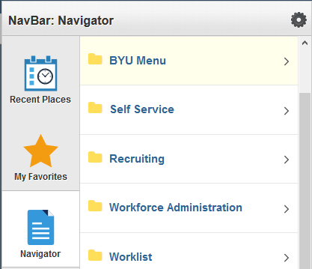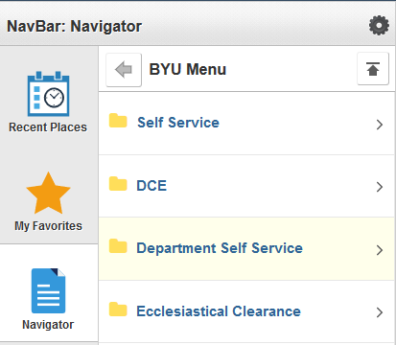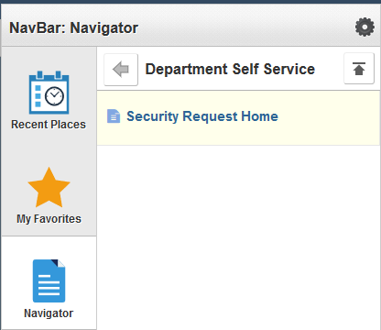

Either navigation should lead to the Security Request Home Page:

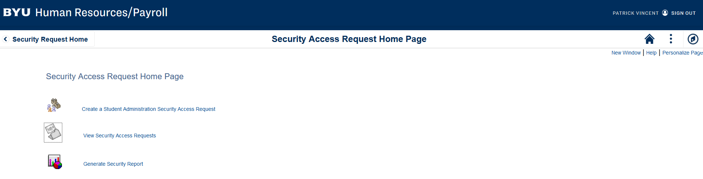

After having successfully navigated to the page, a direct link will appear in the “Recent Places” folder on the NavBar; or if desired a user may save the page into their “My Favorites” folder.

Submitting a Request

To submit a new access request, select the “Create” menu option:

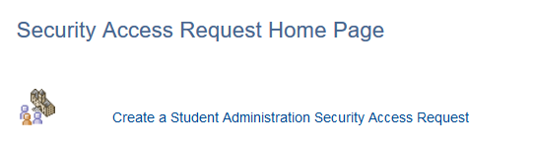

The “Create” menu option is chosen whether submitting an access requests for student employees, staff employees, or administrative employees.
To begin a new access request, click either radio button to enter the employees EmplID or Net ID. A corresponding field label will display, and the input field will validate entry of that information. The spyglass to the right of the input field will display a search window if selected. Security Access Requests can only be submitted for employees in the HR/Payroll system and within the SAC’s department tree.

The SAC will also see a message to confirm the new employees FERPA training is complete.

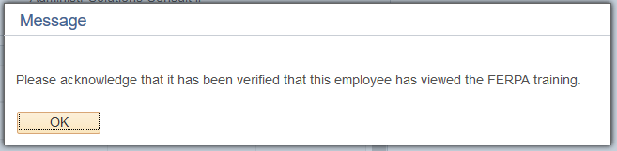
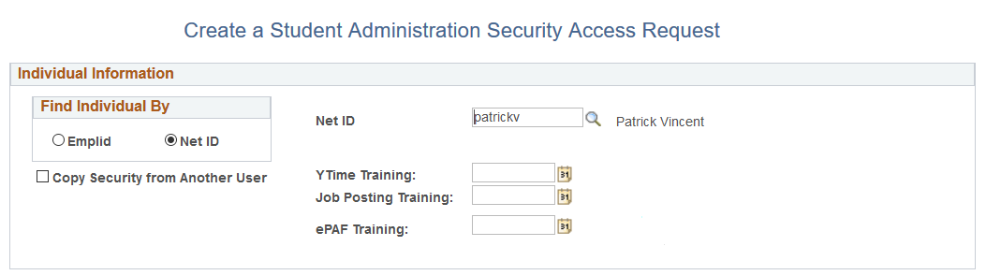

At this point there are two options:

- Copy Security from Another User (check box). This option allows the SAC to input the Net ID of a current employee from which the request can duplicate the system access; the person’s name corresponding to the Net ID chosen to copy will display, however the roles held by the person are not displayed. This option is a bit easier and may be preferable if the security being requested will remain constant for the new employee. If the Net ID being copied is no longer a current employee – no access is copied. The copy option can still be utilized but additional instructions in the comment section may need to be included.

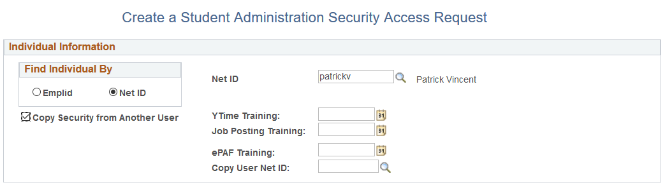

- Manual Role Selection (lower half of screen). This option allows the SAC to select individual roles assignments (check box) for the new employee. The Role Types and Role Names provide a brief description of roles made available to the SAC and are typically defined as responsibilities within the department. Multiple roles may be checked for assignment per access request; the action column will indicate “Add” if selected. If the SAC is unsure of which roles to manually select, they can seek the assistance of the Security Administrator, Department Controller, or Department Administrator for assistance. Or simply utilize the copy option.

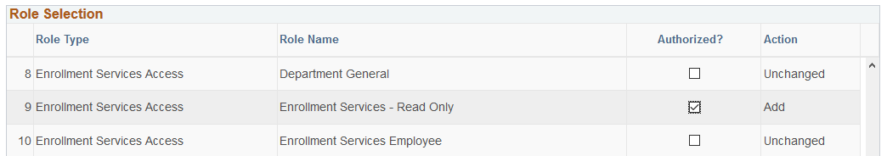

Optionally, a SAC may any additional comments, as necessary. The comments are appended to the request and are viewable by those receiving the request for approval. To complete the request, select the button Submit for Approval.

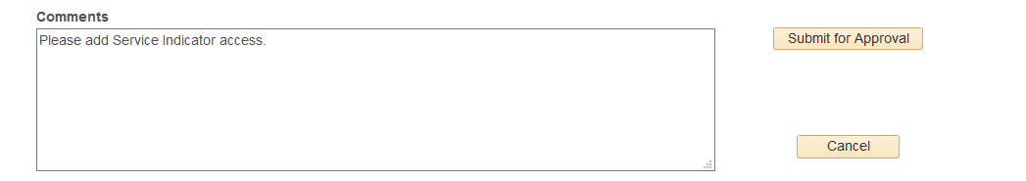

Once the Security Access Request is submitted, the system will notify approvers via email of a request for access to the Student Administration system. The approval process includes verification of employment, the completion of FERPA training, and a review of department access needs. The submitting SAC will also receive an email notification when the approval process has been completed or if more information is required. If no approval email approval has been received by the SAC – please contact the Security Administrator.

If you have any questions, please contact:

Patrick Vincent – patrick.vincent@byu.edu – 801-422-7803
Ed McCracken – Ed_McCracken@byu.edu – 801-422-6628

