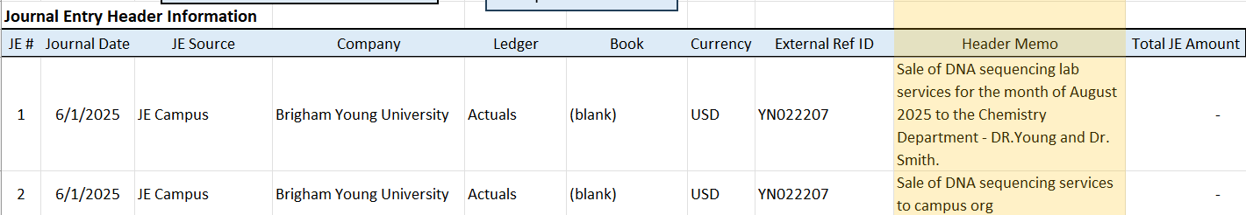

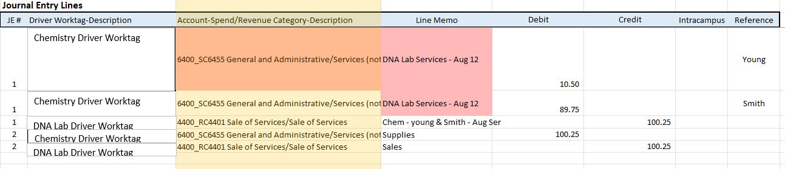
- The Header Memo should include a clear and meaningful description tailored to the user of the financial report where the entry will appear. It should explain what was purchased and identify the party to whom the sale was made. This helps ensure that the purpose and context of the transaction are easily understood. In addition, the Reference column should be used to provide any extra details that support or clarify the entry—such as invoice numbers, contract references, or other relevant identifiers.
Journal Entry 1 is a strong example of how to properly record a transaction. The Line Memo clearly states who the goods or services were sold to, supporting the credit entry. The Header Memo adds helpful context by explaining what was purchased and from whom. This kind of detail makes the entry easy to understand and supports accurate financial reporting.
In comparison, Journal Entry 2 is poorly documented. The Line Memo does not explain what was sold or who the customer was, and the Header Memo lacks important details about the transaction. This makes the entry unclear and less reliable for financial review.
For accurate and useful records, every journal entry should include clear, detailed memos. These should describe what the transaction was for and name the parties involved.

